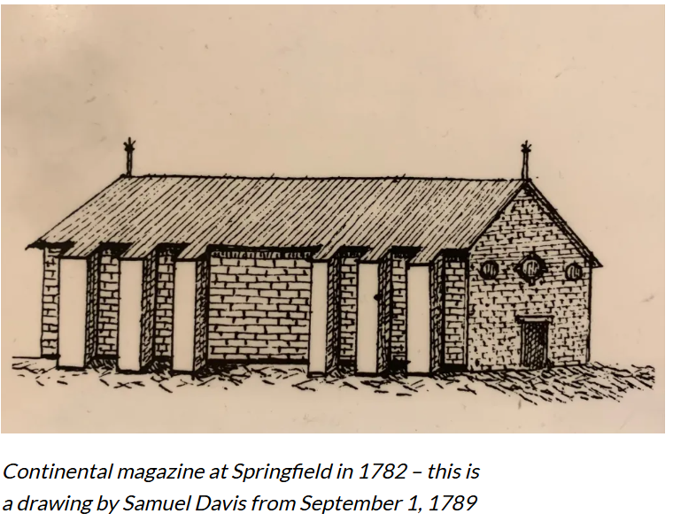
Arsenal Lay out Features
In the language of the day, a magazine was a storehouse, not necessarily for powder alone but for any class of supplies, provisions, forage, etc.

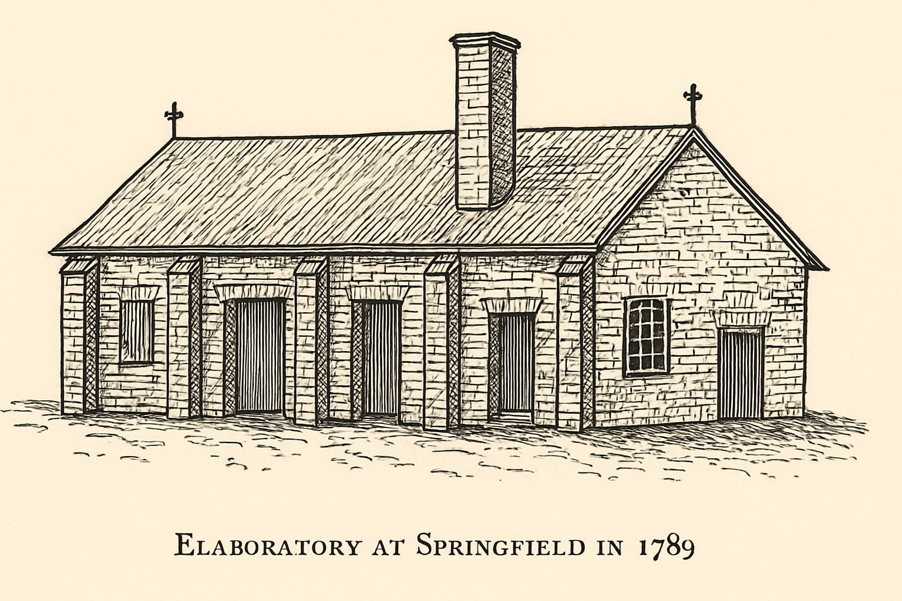
Imagined rendering

The Elaboratory was an establishment for the manufacture of munitions

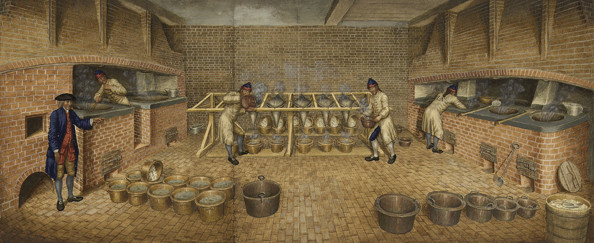
Royal Elaboratory at Woolwich England 1750
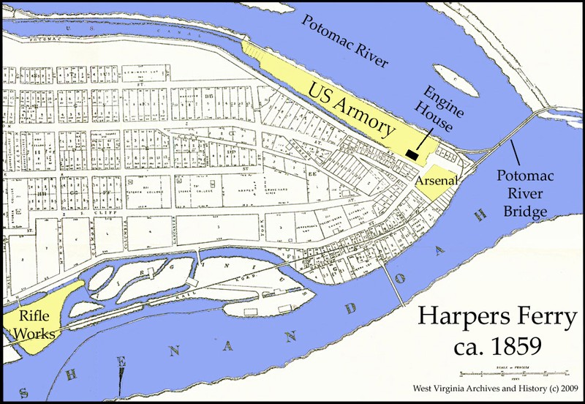
Arsenal Lay out Features (continued)

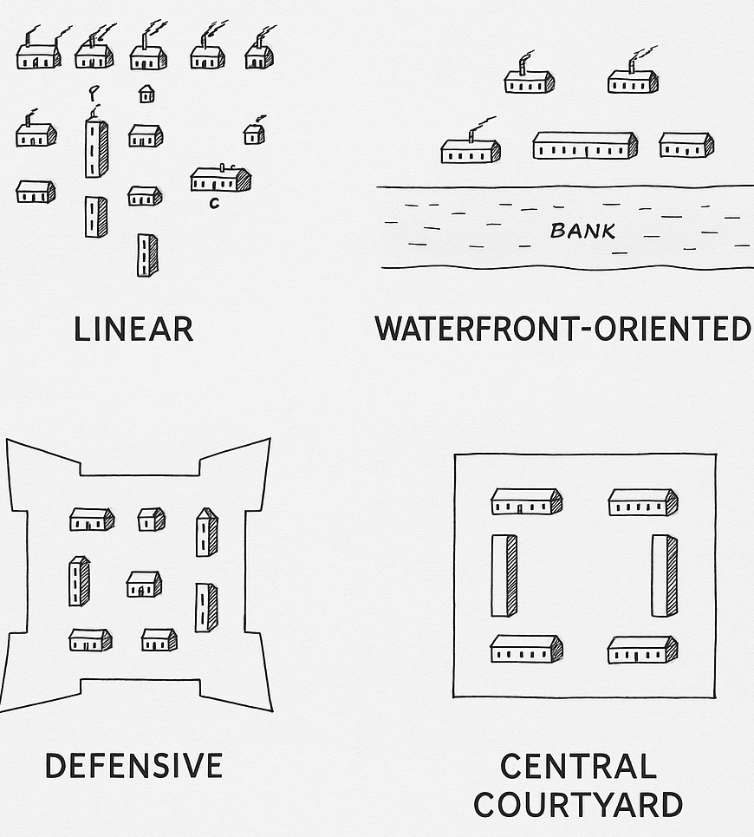

Gunsmiths – repaired damaged muskets and rifles.
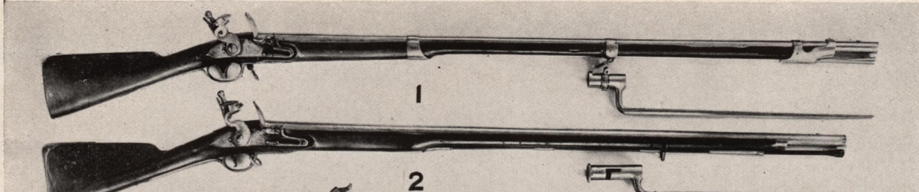

Musket, French, Model 1763, St. Etienne manufacture. 2. Musket, British Brown Bess, captured from Burgoyne's 20th Regiment at Saratoga, 1777

"Pigs" of Lead
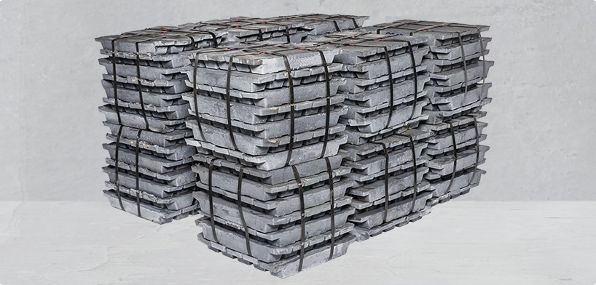
"Pigs" are traditional terms for ingots, or blocks of smelted metal (originally pig iron, due to the shape of the molds resembling a sow and piglets). The Romans produced lead on an industrial scale and cast the metal into these standardized ingots, many of which have been discovered by archaeologists

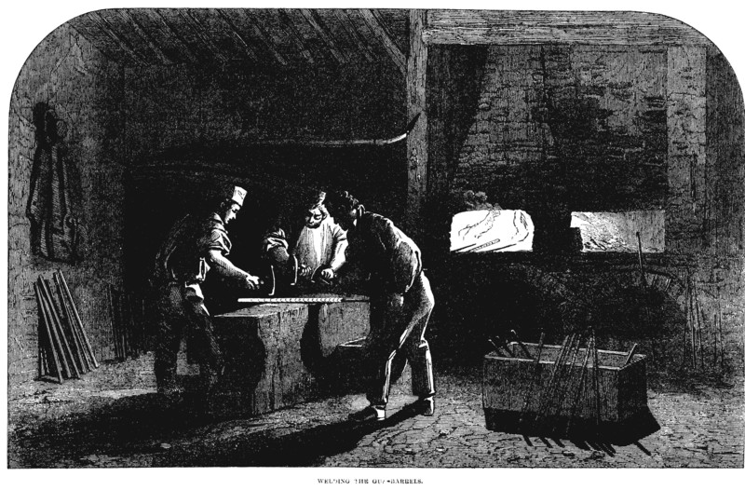
Blacksmiths – forged and repaired metal components.
The work for the armorers was difficult. They often started at 4 AM and then toiled until long after dark. Hammering, filing iron bars on grindstones, working over the blazing forge, planing wood stocks, filing down the gun barrels—it was all labor intensive. And according to payroll records, they worked six days a week.
Typical daily rations were “18 ounces of bread, 1 and 1/4 pounds of beef or 3/4 pounds of pork, 1 gill of rum, whiskey, or other spirits; to each hundred rations were added four pounds of soap, 2 quarts of salt, 2 quarts of vinegar, and 1 and 1/2 pounds of candles. One fourth of the meat had to be fresh.”
Colonial Quills: Springfield Armory Legacy by Elaine Marie Cooper

Powder Makers / Laboratory Workers – filled cartridges, inspected powder, and prepared munitions.
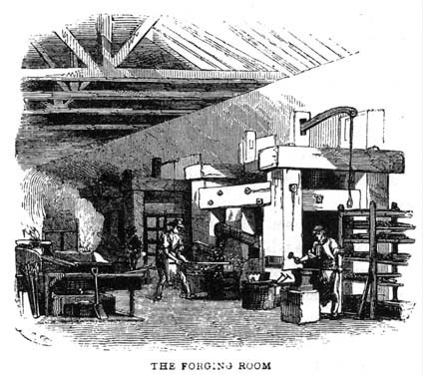
MARCO PAUL AT THE SPRINGFIELD ARMORY, by Jacob Abbott, 1853, p. 17

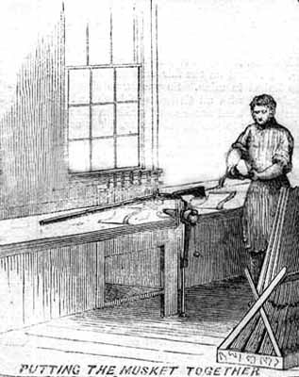
Carpenters – built wooden gun stocks, packing crates, and structures.
A stocker is assembling a musket by cutting into the wooden stock with cutting tools so that the metal pieces will fit correctly. The wooden stock held the pieces in the correct functional relation to each other while allowing the soldier ease of use.
Harpers Wekly, September 21, 1861

